PROJECT SYNOPSIS
Research Area: Document Structure Extraction and Reconstruction for Multilingual Machine Translation
1. Problem Statement
With the rapid growth of digital documentation across government, education, healthcare, and enterprise sectors, multilingual translation has become critical. However, most existing machine translation systems are designed to process one-dimensional plain text strings. They consistently fail to preserve the complex spatial layout of documents, distorting or entirely losing essential elements such as headings, nested tables, figures, text boxes, headers, footers, and logical reading order.
The core challenge is to develop an intelligent, document structure-aware framework capable of automatically extracting, preserving, translating, and accurately reconstructing the formatting and layout of various file types (including DOCX, RTF, PPTX, and PDFs) while maintaining strict structural consistency across multiple languages.
2. Literature Survey
Recent advancements in Document AI and neural machine translation confirm both the feasibility and complexity of this problem.
- Structure-Preserving Workflows: BabelDOC and PDFMathTranslate established the underlying detect-layout → translate → re-render workflow, emphasizing the need to convert documents into an intermediate structural representation before translation.
- Multimodal Layout Understanding: The DIMT25 shared task and models like DREAM frame document reconstruction as sequential stages of layout analysis, reading-order recovery, and content extraction.
- Real-World Case Studies: A 2026 case study on Marathi-to-English government document translation (Waghe et al.) successfully integrated layout-aware OCR and coordinate-based extraction. However, it highlighted that dense tables remain difficult to reconstruct due to translation-induced text expansion—a spatial misalignment risk this project will explicitly address.
- Translation Engines & Benchmarking: IndicTrans2 (AI4Bharat) provides a robust, transformer-based NMT system covering all 22 scheduled Indian languages, serving as the ideal engine for this pipeline. Furthermore, empirical analyses (Rajaee et al., 2026) and the M3T multimodal benchmark dataset demonstrate that machine-translated test sets are highly reliable for evaluating layout-aware document translation.
3. Research Gap
Existing pipelines treat layout extraction and linguistic translation as uncoordinated stages. There is a lack of a unified framework that can seamlessly extract hierarchical structural metadata, map it to sequential text for translation, and dynamically reconstruct the output document without requiring extensive manual reformatting.

4. Objectives
- Extraction: To automatically extract text and structural elements (headings, paragraphs, tables, lists, text boxes) from complex documents (DOCX, PDF, PPTX) while preserving logical reading order.
- Data Structuring: To isolate layout metadata from textual content using structured data formats, preventing formatting loss during the linguistic processing phase.
- Translation: To translate the extracted text using highly accurate multilingual NMT engines via API-based inference, keeping structural coordinates intact.
- Reconstruction: To reconstruct a translated output document that mirrors the original layout, incorporating adaptive handling for text-length expansion in constrained layout regions like tables.
- Implementation: To deliver the pipeline as a scalable walking-skeleton MVP (Phase 1: DOCX-first), extending to richer visual elements (PDFs via OCR) in subsequent phases.
5. Possible Approach
The framework will follow a sequential, five-stage modular pipeline: Upload → Extract → Structure → Translate → Reconstruct.
Phase 1: Frontend Interface & User Interaction
- Developed using React.js to provide a responsive and intuitive user interface.
- Enables users to securely upload multi-format documents (DOCX, PDF, PPTX) and select the desired target language.
- Features a real-time status dashboard for users to monitor the extraction and translation progress continuously.
Phase 2: Document Extraction & Parsing
- Powered by a FastAPI backend utilizing advanced parsing libraries such as PyMuPDF and python-docx.
- Implements a dynamic evaluation step for PDF inputs to distinguish between native (text-embedded) and scanned (image-based) documents.
- Routes scanned PDFs through PaddleOCR for robust optical character recognition and text extraction.
- Processes structured formats (DOCX, RTF, PPTX) and native PDFs directly without the OCR overhead.
- Captures critical spatial metadata simultaneously, including layout blocks, bounding box coordinates, and logical reading order.

Phase 3: Intermediate Data Structuring
- Converts all extracted text and layout elements into a unified, hierarchical JSON representation.
- Isolates the raw textual content from formatting attributes (font size, style) and spatial coordinates.
- Utilizes JSON due to its lightweight, language-independent, and API-friendly nature.
- Acts as a structural bridge, ensuring seamless data transfer between the extraction and translation modules without losing document fidelity.
Phase 4: API-Based Translation & Cache Management
- Routes the structured text segments from the JSON file to advanced NMT engines like IndicTrans2 or Meta NLLB via API endpoints.
- Manages the translation workload asynchronously using FastAPI's built-in BackgroundTasks to ensure the user-facing request is never blocked.
- Implements Redis to cache frequently translated text segments, significantly improving response times and eliminating redundant computational costs.
- Includes a scalability roadmap to migrate from BackgroundTasks to a Celery-based distributed task queue for handling high-volume enterprise workloads in the future.
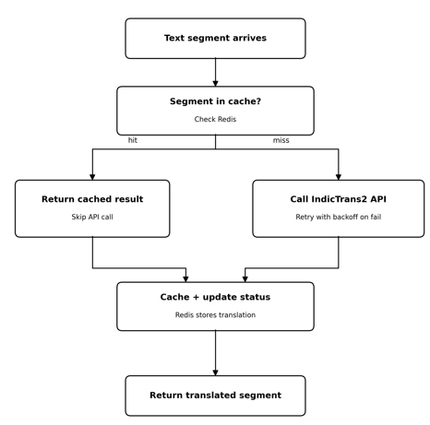
Phase 5: Layout Reconstruction & Output Generation
- Maps the newly translated text segments back to their exact original spatial coordinates using the stored JSON metadata.
- Employs ReportLab for rendering complex PDF layouts and python-docx for reconstructing Word documents.
- Integrates adaptive formatting rules to automatically handle translation-induced text expansion, especially within constrained layout regions like nested tables.
- Compiles the final visually consistent document and securely delivers it to the user for download.

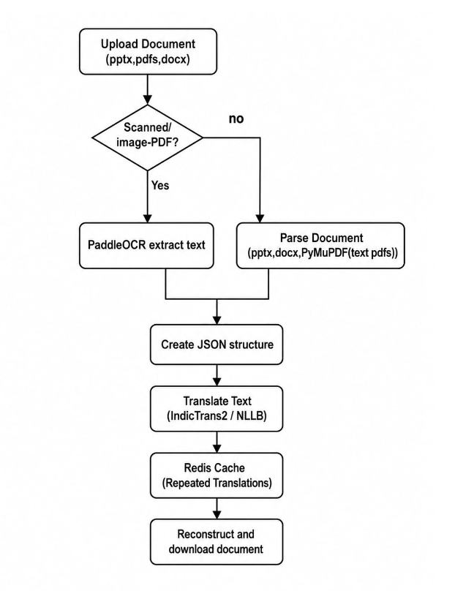
6. Required Resources
Software & Frameworks
- Frontend: React.js, Tailwind CSS, JavaScript, Axios.
- Backend & Task Management: Python (FastAPI), Redis.
- Document AI & Parsing: python-docx, python-pptx, PyMuPDF, PaddleOCR.
- Structured Data Format: JSON.
- Document Reconstruction: ReportLab.
- Development Tools: VS Code, Git, GitHub, Postman.
AI Models & Datasets
- AI Frameworks & Models: PyTorch, Hugging Face Transformers, IndicTrans2, Meta NLLB-200.
- Open-Source Datasets: M3T Dataset, DocLayNet (for benchmarking and testing).
7. Expected Outcomes & Impact
- Structural Fidelity: Successfully preserves complex document layouts, tables, and stylistic formatting during end-to-end translation.
- Efficiency: Drastically reduces the manual document reconstruction and formatting effort typically required post-translation.
- Accessibility: Delivers a lightweight, hardware-efficient solution capable of running on standard commercial systems.
- Domain Impact: Improves productivity for localization teams, e-governance applications, and administrative workflows by automating the translation of official records and reports.
8. References
- O'Brien, D. et al. (2025). BabelDOC: Layout-Preserving Document Translation via Intermediate Representation. arXiv.
- Waghe, M., Chandargi, D., Rayyan, M. A., Joshi, R., & Deshpande, A. R. (2026). Structure-Preserving Document Translation via Multi-Stage LLM Pipeline: A Case Study in Marathi. arXiv preprint.
- Ouyang, R., Chu, C., Xin, Z., & Ma, X. (2025). PDFMathTranslate: Scientific Document Translation Preserving Layouts. EMNLP 2025 System Demonstrations.
- Gala, J., et al. (2023). IndicTrans2: Towards High-Quality and Accessible Machine Translation Models for all 22 Scheduled Indian Languages. arXiv preprint.
- Hsu, B., et al. (2024). M3T: A New Benchmark Dataset for Multi-Modal Document-Level Machine Translation. NAACL.
- Rajaee, S., Choenni, R., Shutova, E., & Monz, C. (2025). An Empirical Analysis of Machine Translation for Expanding Multilingual Benchmarks. WMT 2025.

